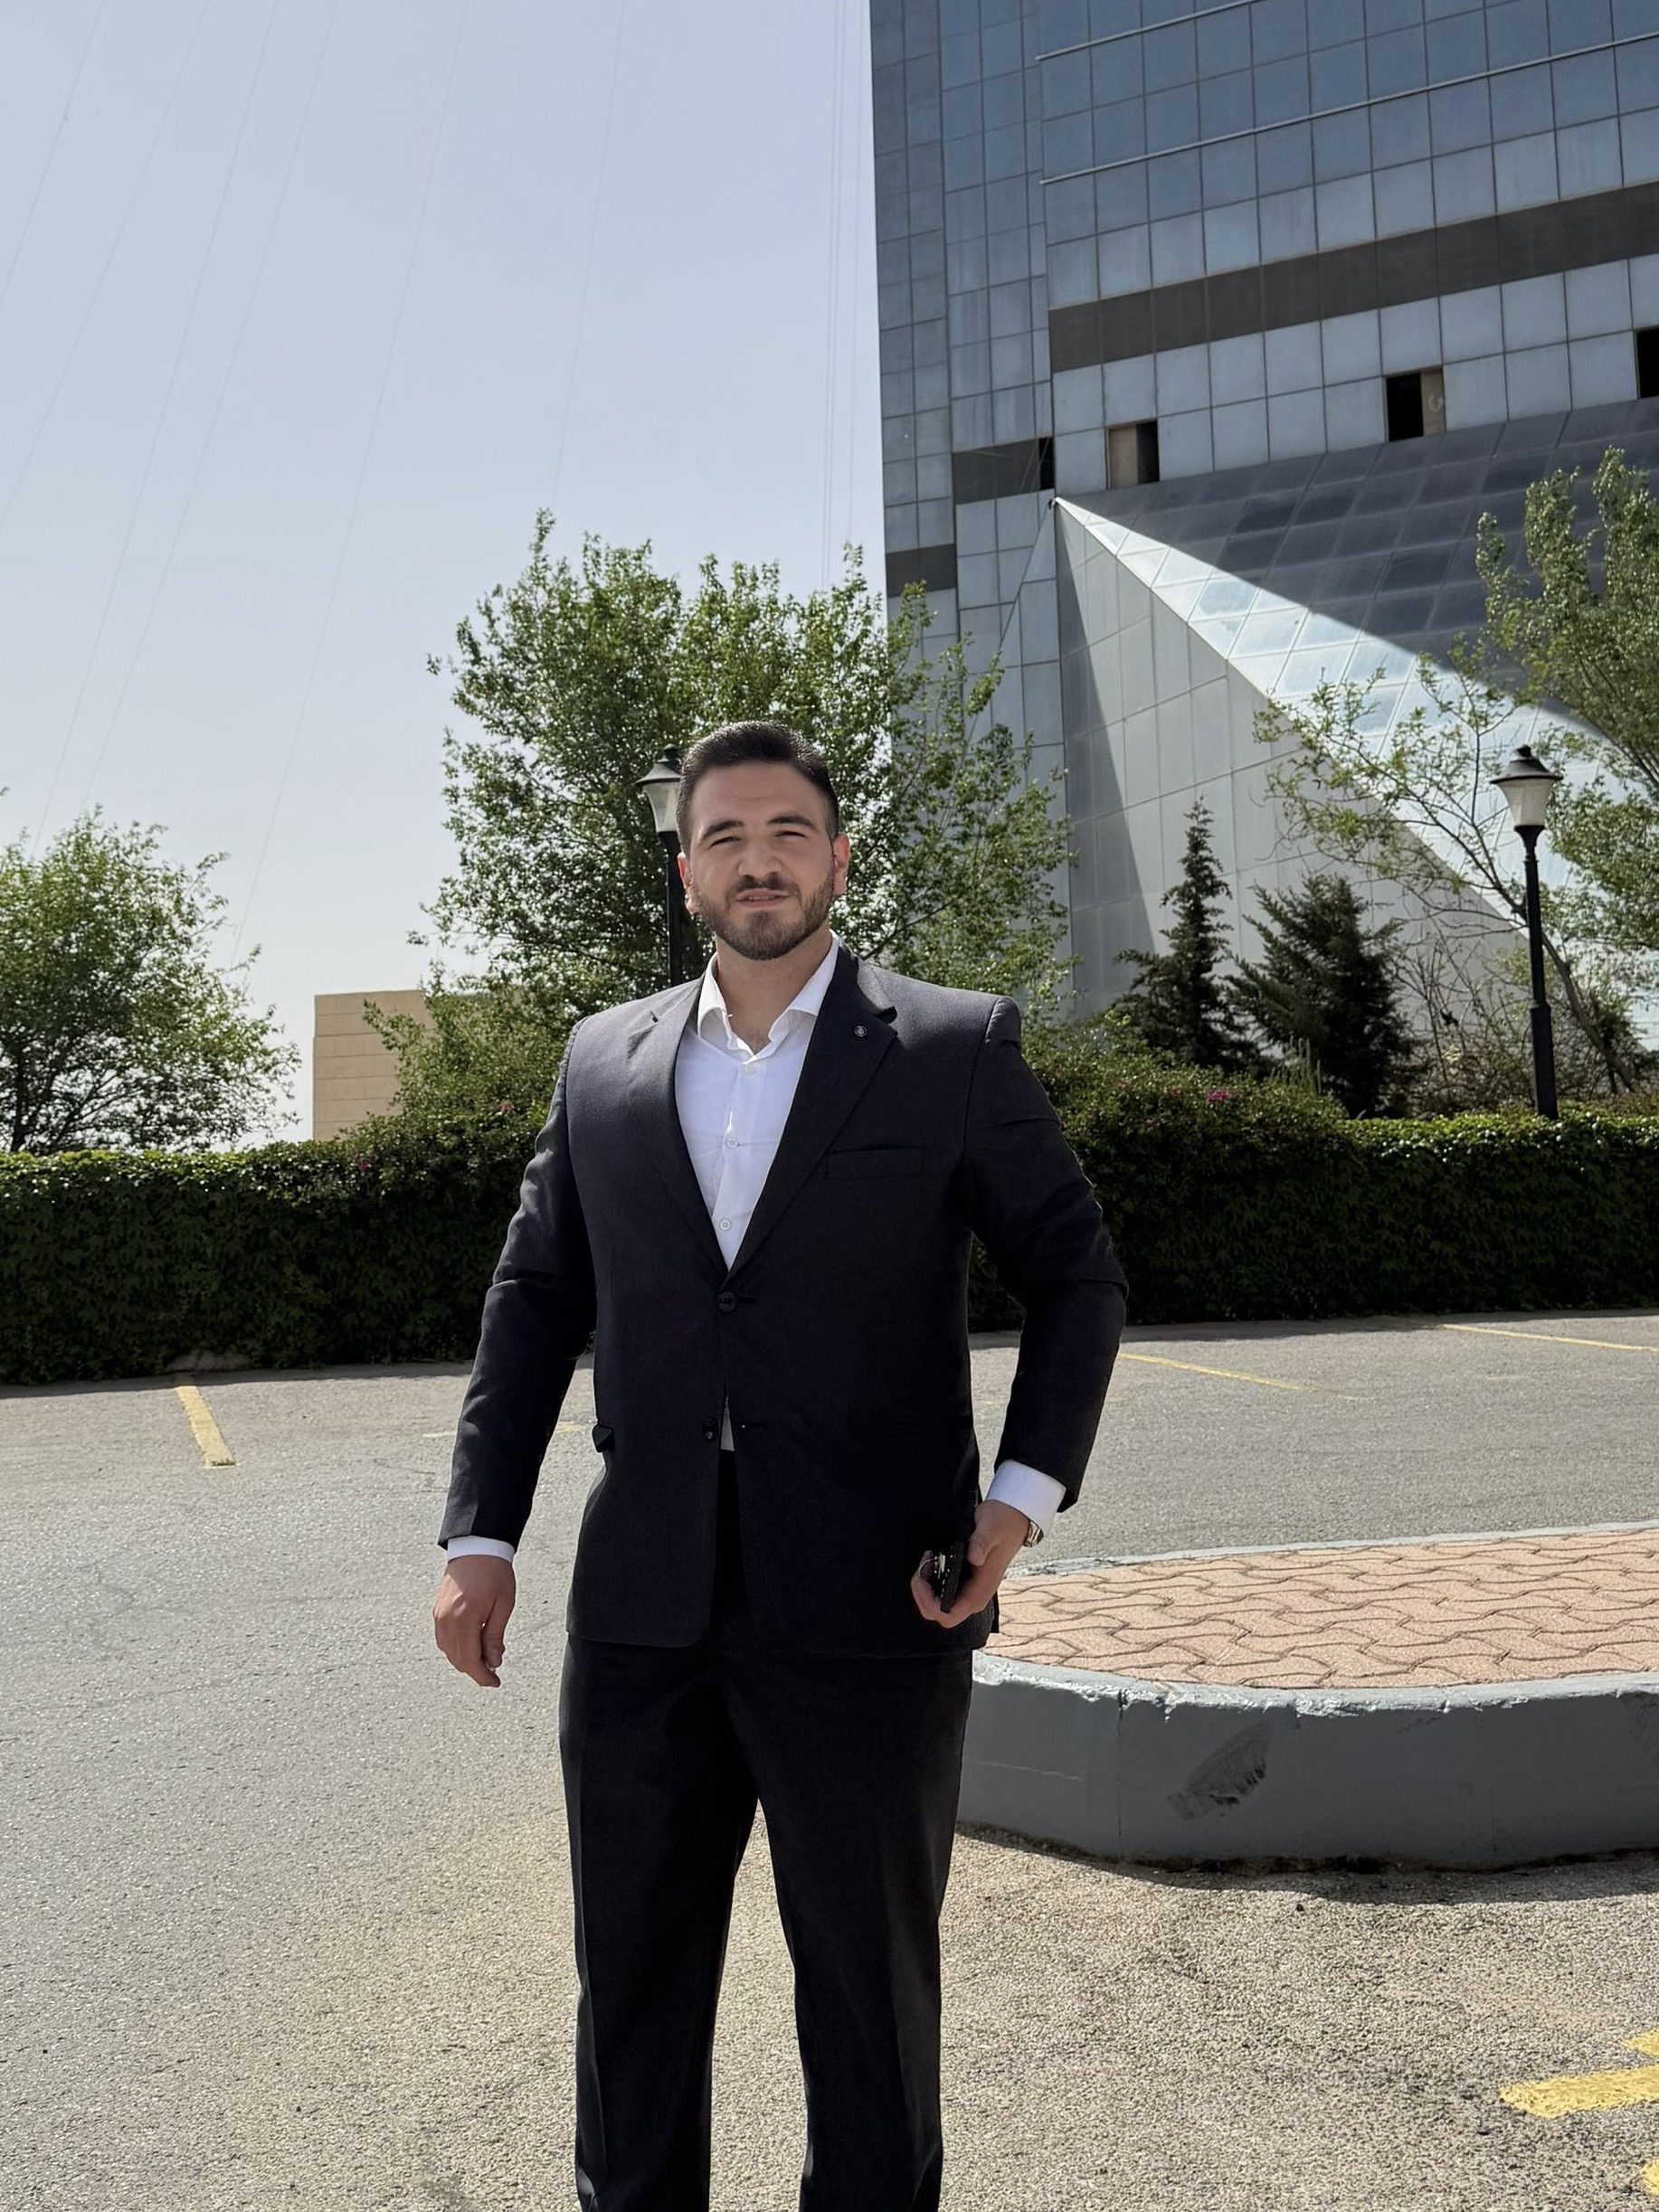
JAWAD ABDEEN
Accountant
📍 Jabal Amman, Amman, Jordan | ✉️ jawadabdeen003@gmail.com | 📞 0797776845
PROFESSIONAL SUMMARY
Detail-oriented and results-driven Accountant with hands-on experience in financial management, administrative operations, and office coordination. Proven ability to streamline accounting processes, manage center operations, and apply strong problem-solving skills to enhance organizational efficiency. Adept at leveraging advanced spreadsheet applications and cross-functional collaboration to deliver accurate financial outcomes.
WORK EXPERIENCE
Accountant • Al-Saber Office [2024 - Present]
Amman, Jordan
- Manage daily accounting transactions, journal entries, and financial record-keeping with 99% accuracy.
- Reconcile bank statements, accounts payable, and accounts receivable to ensure financial integrity.
- Prepare monthly financial summaries and reports to support management in strategic decision-making.
Administrative Trainee • LOYAC [2024 - 2026]
Amman, Jordan
- Completed a comprehensive 2-year professional administrative training program focusing on corporate operations and workflow optimization.
- Assisted senior management in organizing cross-departmental projects, improving operational efficiency by 15%.
- Handled professional correspondence, scheduling, and documentation while maintaining strict confidentiality.
Accountant & Center Manager • Rawad Al-Dahiyeh Tutoring Center [2021 - 2024]
Amman, Jordan
- Directed overall center operations, student affairs, and financial accounting functions for over 3 years.
- Oversaw tuition fee collection, budgeting, and payroll processing, reducing financial discrepancies by 20%.
- Streamlined administrative and accounting workflows, enhancing communication between staff, parents, and management.
EDUCATION
Bachelor's Degree in Accounting • The Hashemite University [2021]
CORE SKILLS & EXPERTISE
Accounting & Finance: Financial Accounting • Bookkeeping • Bank Reconciliation • Accounts Payable/Receivable • Budgeting & Payroll
Technical & Software: Microsoft Excel • Microsoft Office Suite • Computer Literacy • Professional Email Correspondence
Soft Skills & Competencies: Leadership • Problem Solving • Time Management • Teamwork & Collaboration • Communication Skills
CERTIFICATIONS
- Communication Skills Workshop - Professional Development Center (2022)
- CV Writing and Interview Skills Workshop - Career Development Program (2022)
LANGUAGES
Arabic (Native) • English (Intermediate)

